Angel Almanzar
Professor Holden-Gouveia
Data Management
10/29/25
Create your own Visualizations

1. Going back to the Halloween candy data, pick 1 thing that you think would be better illustrated using a visualization. Create your visualization using whatever software you like, this could be an online chart maker, or a spreadsheet or anything.

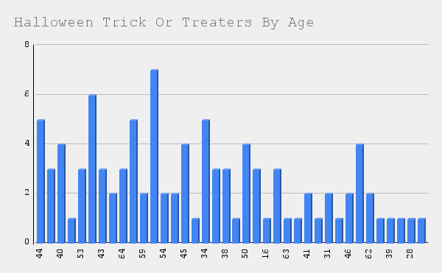

This is the count of the ages of the participants for Halloween trick or treaters, from the Halloween candy data set. It is useful information to know the age range of who is participating. There is a range of ages and the amount of that age is represented by the line on the left from 0-8. For example, there were more participants from the age range of 54-59 based on the chart.

2. Explain why you picked that 1 thing, and explain how you decided which visualization to use and why.

I chose the age range because I thought that data would be better represented on a chart. I thought a bar graph is good to see it in a visualization, it shows a wider range of numbers and more data than a pie chart or another chart.

3. Go back to the data you collected/found and pick 2 things that you think would be better illustrated using a visualization. Create your visualization using whatever software you like, this could be an online chart maker, or a spreadsheet or anything.
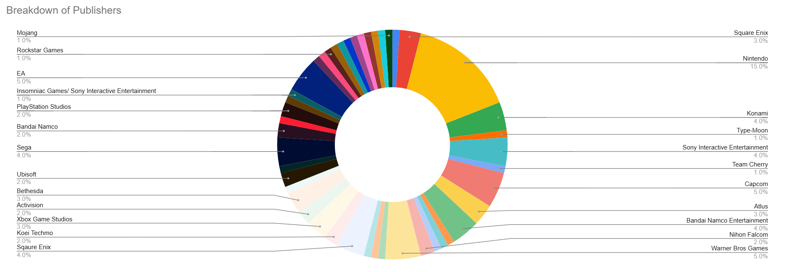
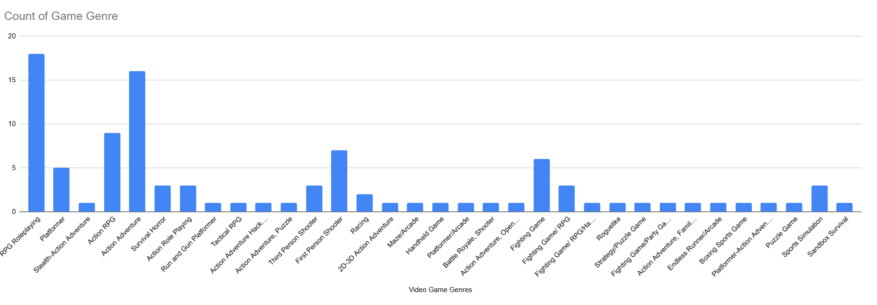

4. Explain why you picked those 2 things from your data, and explain how you decided which visualization to use and why.

I made my two visualizations from my “Best Selling Games By Franchise” data set. The first visualization is a breakdown chart of the publishers column, which publisher's games appeared the most. I chose this for my visualization because I thought it would be important to see this information as an image to show which publisher had more games on the data set.
My second visualization was “Count of Game Genre”. I chose this because I thought it would be interesting to see this as a visualization. It would also be useful to see this information visualized, to get a better understanding of which genre is more popular or frequent within the data set.

